Budker Institute of Nuclear Physics SB RAS

G. Derevyankin, G. Dimov, V. Dolgushin, A. Dranichnikov, G. Kraynov, A. Krivenko, V. Palchikov, M. Petrichenkov, E. Pohlebenin, R. Salimov, G. Silvestrov, S. Taskaev, V. Shirokov

Charge-exchange target for 40 mA 2 MeV tandem accelerator
BINP 2001–23

Novosibirsk
2001

Charge-exchange target for 40 mA 2 MeV tandem accelerator
G. Derevyankin, G. Dimov, V. Dolgushin, A. Dranichnikov, G. Kraynov, A. Krivenko, V. Palchikov, M. Petrichenkov, E. Pohlebenin, R. Salimov, G. Silvestrov, S. Taskaev, V. Shirokov
Budker Institute of Nuclear Physics, SB RAS, Novosibirsk, Russia
An electrostatic tandem-accelerator with vacuum insulation with energy of protons up to 2.5 MeV and current up to 40 mA is under development at BINP. The charge exchange target is one of component parts of this accelerator. It converts negative hydrogen ions accelerated to half of total energy into protons.
An analysis of application of different targets has been made. The regimes of gas flow from the charge-exchange tube are considered. The gas pumping out possibilities are analyzed. The effects of interaction of ion beam with gas target are considered. The program of further experiments is defined.
© Budker Institute of Nuclear Physics SB RAS

The electrostatic tandem-accelerator with vacuum insulation is under development in frames of the project of creation of neutron source for neutron capture therapy of cancerous tumors [1]. It is designed for proton energy up to 2.5 MeV and beam current up to 40 mA (Fig. 1). One of the parts is the target, which converts negative hydrogen ions accelerated to half of the total energy into protons. The target in solid, liquid or gaseous state should satisfy the following requirements:
1. It should provide 98 – 99 % stripping of hydrogen negative ions beam with energy from 0.96 to 1.25 MeV into protons.
2. It should not lead to proton spectrum widening more than by 2 keV.
3. The vacuum deterioration in accelerating gap should not cause neither decrease of electrical strength of vacuum gap nor the potential redistribution on the electrodes of accelerating gap by the additional current on the electrodes. It is considered [2], that 10^{–5} torr pressure ensures the high voltage strength of accelerating gaps, but 10^{–4} torr pressure degrades the tandem operation reliability because of the breakdowns of high voltage vacuum gaps.
4. The preliminary numerical simulations of cold H⁻ beam transportation show that the use of magnetic or electrostatic decelerating lens before the tandem entrance allows to transport 25 mA beam 6 mm in diameter through 400 mm length in the target region. Therefore the aperture of stripping target should be more than 6 mm.
The analysis of targets of different types for application in accelerator-tandem is given in this work. The gas flow regimes from the stripping tube and the estimations of gas density in accelerating tract are considered. The possibility to pump the target gas by outer pump and pump placed directly inside the high voltage electrode are investigated. The effects of ion beam and target gas interaction are considered. The analysis of thermal regimes of stripping tube is made. The program of the following experiments is defined.
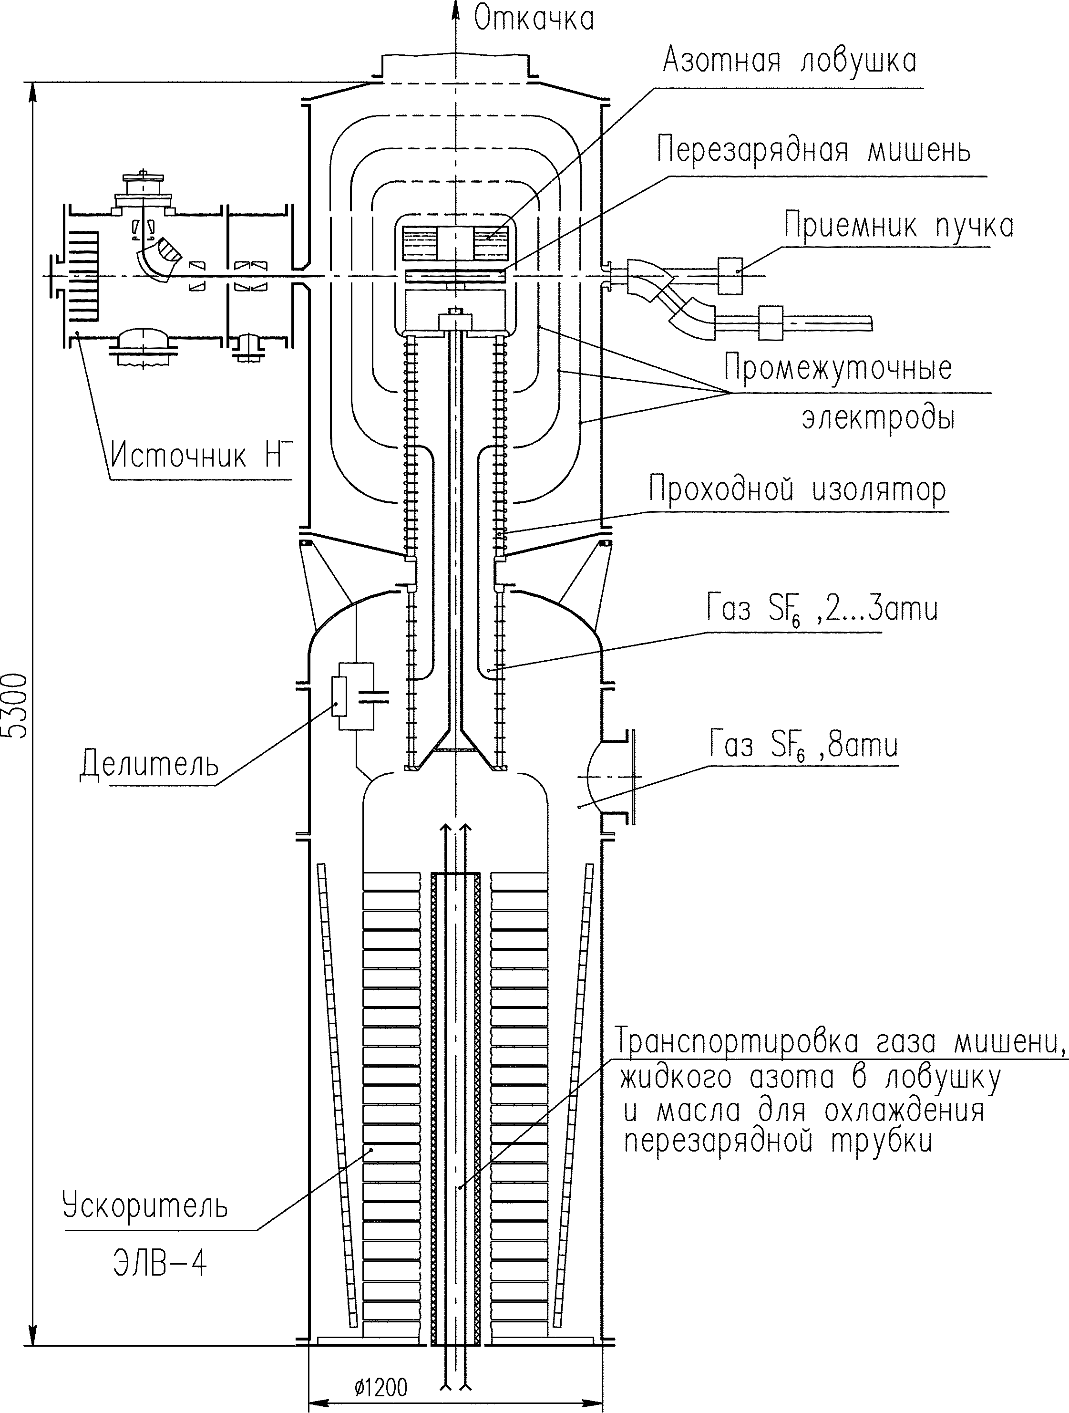
Рис. 1. Common view of accelerator -tandem.

Solid targets
The graphite foil of 0.1÷1 μm thickness is usually used as a stripper for H⁻ ions with energy higher than 400 MeV and current ~ 0.1 mA. At an achieved foil temperature 900 °K the saturated vapors pressure is very low, less than 10^{–10} torr [3], so the lifetime of the target is several weeks [4]. For passage of 1 MeV 40 mA beam 10 mm in diameter through 1 μm graphite foil the ionizing energy losses are 40 keV [5], and foil without forced cooling is heated up to 3800 K temperature with corresponding increase of saturated vapors pressure up to 10 torr [3]. Big energy spread of ion beam after stripping, limited lifetime of the foil and big pressure of saturated vapors at high temperature does not allow to use graphite foil as a stripper.

Liquid metal targets

A big experience in dealing with liquid lithium has been accumulated at BINP [1, 7, 8]. The velocity of liquid lithium jet target 1 μm thick and 10 mm wide flowing perpendicular to the accelerated ion beam should be more than 100 m/s taking into account the maximum allowed temperature of lithium 320 K when the saturated vapors pressure reaches 10⁻⁵ torr value. It is achievable. The lithium jet heating by the beam results in change of flow regime in jet and decrease of jet density. It is proposed that application of jet as a stripping target will be considered after planned experiments with liquid lithium neutron producing thick jet and after numerical simulations in hydrodynamical approximation.
Vapor target
The simplicity of creation the target based on heated magnesium vapors, low pressure of saturated vapor (less than 10⁻¹⁰ torr at 20 °С [3]), which are condensed after exiting the stripping tube on the structural elements of the installation together with lack of necessity of vacuum pumping allow to consider magnesium vapors target as a most preferable for application in low voltage installations [6]. However, in given case, magnesium falling into accelerating tract with 40 g/month rate and settling on the electrodes surface will decrease the breakdown strength of vacuum gaps [2].

Steam-jet targets
It is possible to use the transversal sonic or supersonic metal steam jets with circulation [9, 10] as a stripping targets with big acceptance. In this case a steam condensed into liquid is pumped to the heater on the output of a nozzle. The mercury vapors coming from the stripping target can be pumped by cryogenic pump. The use of mercury requires the additional safety measures to be undertaken and the use of lithium proposes checking of the vacuum gaps breakdown strength conservation.

Gaseous targets
For stripping of H⁻ ions with 1 MeV energy into protons any gaseous target is suitable, practically, because it allows almost 100 % beam conversion into protons [12, 9, 23]. The corresponding data about cross-sections and equilibrium protons output is given in Table 1
Table 1. Cross-sections connected with stripping of 1 MeV H⁻ ions on different gases and equilibrium protons output F_{+∞} [12, 9 (italic), 23 (underlined)].
gas | σ_{– 0}, cm² | σ₀ ₊, cm² | σ_{– +}, cm² | σ_{0 –}, cm² | σ₊ ₀, cm² | σ_{+ –}, cm² | F_{+∞}, %
H₂ | 7,2 10^{–17} | 1,7 10^{–17} | 3,5 10^{–18} |  | 4,6 10^{–22} | 2,6 10^{–28} | 99,9946
He | 4 10^{–17} | 1,5 10^{–17} | 1,3 10^{–18} |  | 3,6 10^{–21} |  | 99,9640
N₂ | 3 10^{–16} | 1,5 10^{–16} | 4,7 10^{–17} | 2 10^{–18} | 6 10^{–20} | 6 10^{–24} | 99,9925
O₂ | 3,6 10^{–16} | 1,5 10^{–16} | 1,7 10^{–17} |  | 7,5 10^{–20} |  | 99,9931
Ar | 4,2 10^{–16}  3,6 10^{–16} | 1,6 10^{–16}  1,3 10^{–16} | 2,2 10^{–17} | 6 10^{–21} | 8 10^{–20} | 1,7 10^{–24} | 99,9880
Мg | 1,6 10^{–16} | 1,3 10^{–16} | 8,4 10^{–17}
CO₂ | 5,2 10^{–16}  3,7 10^{–16} | 1,4 10^{–16} | 2,0 10^{–17} |  | 9 10^{–20}
Kr | 3,6 10^{–16} | 1,5 10^{–16} | 2,5 10^{–17}
Xe | 4,4 10^{–16} | 1,8 10^{–16} | 3,8 10^{–17}
SF₄ | 1,5 10^{–15} | 6,3 10^{–16} | 9,4 10^{–17}
CCl₂F₂ |  | 5,2 10^{–16}

Gases mentioned in two last strings of Table 1 require some comments. The fact is that geometrically all diatomic and most part of triatomic molecules are linear. Therefore fast incident particle interacts effectively only with one of the atoms, because the probability of molecule orientation along the trajectory of fast incident particle is very small. The probability of interaction during collision of fast particle with polyatomic space-structured molecule such as CCl₂F₂ or SF₄, is weakly dependent on molecule orientation. Therefore not numerous experimental data [23] indicate the significant excess of their stripping cross-sections over the ones for di- and tri- atomic molecules.
We suppose that stripping cross-sections on the other compact space-structured molecules, halogenides, TaBr₅, SF₅, SF₆, containing more than 5 atoms of halogen, will be more by 20 – 40 % than for SF₄. Besides the big stripping cross-section such molecules are attractive by the fact that atoms capable to release in solid phase are well hidden in the molecule depth. Because the products of dissociation of the main molecule – halogen atoms and halogenides of lower kind are in general volatile the appearance of solid sediment will be minimal. At the same time the exoticism of application of such a target doesn't allow to choose it without preliminary experiments.
Physically, the target is a cylindrical pipe with gas input in the middle. During beam passage through the target the charge-composition of the beam is being changed. The typical dependence of beam charge-composition vs. target thickness is given in Fig. 2, and the protons yield is given in Table 2.

i, ref. units.  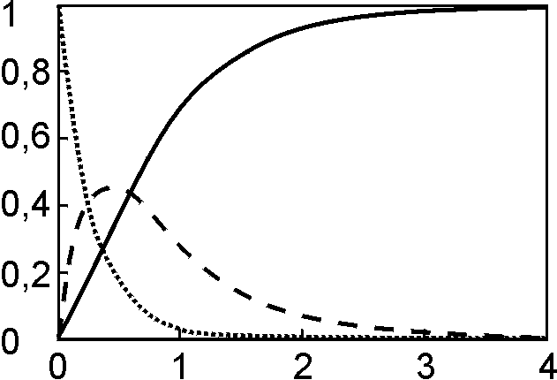  nl, 10¹⁶ cm^{–2} | Fig. 2  Dependence of beam charge composition on thickness of nitrogen target: H⁻ ions (dotted curve), H⁰ atoms (dashed-curve), protons (solid curve).

Table 2. Thickness of target (×10¹⁶ cm^{–2}) made of different gases for the desirable proton yield.
Proton yield % | 90 | 95 | 99 | 99,9
N₂ | 1,8 | 2,2 | 3,3 | 4,7
Ar | 1,7 | 2,1 | 3,1 | 4,5
CO₂ | 1,9 | 2,4 | 3,5 | 5
SF₄ | 0,4 | 0,54 | 0,8 | 1,1

Argon gas target
Let us consider argon gas stripping target. It's choice is conditioned on the fact that argon is a rare gas and, that's the most important, because the stripping is not accompanied by dissociation leading to undesirable heating and appearance of interfering dissociation products.
For 99% beam stripping the linear thickness of the argon gas target L = 3,1  10¹⁶ cm^{–2} is necessary. It corresponds to the average pressure p = <nL>kT/L, the practical expression for which at a room temperature looks enough simple as:
<P> [Torr] = 0,94 L^{–1} [cm]. For example, for the stripping tube with L = 40 cm the average pressure <P> = 2,3 × 10^{–2} Torr. In the considered tube length range of 20 – 40 cm the free path λ > L/375 is more than 0,5 mm. It's considered [14, 15], that for free path of molecules λ < 0,01 D, where D — tube diameter, the viscous flow regime is realized and for λ > 0,33 D — molecular, when molecules move free without noticing each other, colliding with the walls of tube and reflecting from them. For 0,01 D < λ < 0,33 D the intermediate flow regime has place. In given case for tube of 40 cm length and 10 mm in diameter the free path is λ ≥ 0,1 D, so in the center of the tube the intermediate flow regime is realized, while on the tube ends – the molecular one.
Let us estimate the gas flow in molecular regime. The tube conductance is defined as U_{m} [l/s] ~ 10 α D³ L^{–1} [15], where all dimensions are in centimeters, and α – Clausing coefficient, which takes into account the reduction of conductance due to flow before the tube input and flow after exiting the tube. It depends on relation L/D and in given case it's equal to 0,91. However, owing to gas input into the tube directly, α must be taken bigger, so for the upper estimation α = 1 will be considered. Because gas is inputted in the middle of the tube and flows out through both ends, the gas flow is defined as Q = 2 P₀ U, where conductance U is defined on the length two times less than one of the stripping tube, and P₀ – is the pressure in the middle, which is two times bigger than the average one <P>, because pressure is distributed along the tube linearly [16]. Then the gas flow is Q = 46 mTorr l/s. Numerical simulation undertaken using test particles method without taking into account their collisions with each other gives the 1.6 times less gas flow.
Let's take into account the influence of intermediate gas flow mode. The conductance U_{mv} can be expressed through itself in molecular mode U in the form convenient for comparison [17]:
U_{mv} = U (0,074 + ζ ) = U (14 + ζ ),
Here ζ is a weakly dependent function of pressure, temperature, gas viscosity and pipe diameter and varies from ζ = 1 for molecular flow mode to ζ = 0,81 for viscous one. In case under consideration λ = 2,1 mm and и U_{mv} ≈ 1,2 U_{m}. So the gas flow is increased by 20 % and is equal to Q = 55 mTorr l/s, that corresponds to the particle flux 1,8  10¹⁸ s^{–1}.
The gas flow can be reduced by 1.6 times, if one allows 95 % beam stripping, the reduction occurs owing to both pressure decrease and approaching the flow regime to molecular one. In addition the gas flow can be reduced twice as it was shown in [1], using the special form of the internal surface of the stripping tube. One can see that the operation regime with 20 mTorr l/s gas flow from the stripping tube can be expected. The value of this gas flow is yet comparable with gassing from the surface of electrodes.
To sum up let write the expression for gas flow of any gas in our parameters range and pay attention to its dependence on length and diameter of the striping tube.
$Q=3×{\text{10}}^{−\text{18}} \text{nL} \frac{D^{3}}{L^{2}}\frac{T^{1,5}}{\sqrt{M}}\left(4,8×{\text{10}}^{−\text{16}} \text{nL} \frac{D}{L} + ζ\right)$,
where gas flow Q is expressed in l Torr/s, all dimensions are in centimeters, temperature T in Kelvin degrees, M – molecular mass. In order to decrease the gas flow it's necessary to tend to reduce diameter and increase the tube length to realize the molecular flow regime. The realization of flow regime close to viscous is undesirable due to the following effect too. Beam stripping leads to significant gas heating. And if in non-collisional regime the heating of separate molecules can be easily removed by cooling the stripping tube because hot molecule quickly hits the tube wall and transmits the most part of it's energy to it, but in viscous, collisional mode as it's well known [18, 19], the heating of sub-sonic jet leads to its acceleration and density decrease that will demand the bigger gas flow.
Let us determine the pressure inside the central electrode of the accelerator with 7 intermediate electrodes (See Fig. 1) at a high pumping rate of the external pumps. The hole 20 cm in diameter in the high voltage electrode provides the conductance 3000 l/s and can be increased by increasing its diameter. The holes in other 7 electrodes, made as covers with diameter not less than 50 cm, raised a little by 4 cm provide the conductance 6000 l/s. If these holes 50 cm in diameter are made as a jalousie or sectors than the conductance will be increased to 12000 l/s. One can see that conductance through the electrodes with holes installed in series can be got on level 1500 l/s. Therefore, pressure inside high voltage electrode can be 3,5  10^{–5} Torr at a gas flux 55 mTorr l/s, that is admissible.
So, if it would be possible to transport the beam less than 10 mm in diameter on 400 mm length, in this case the use of the argon gas target would be allowable and attractive by the simplicity of realization.

Cryogenic pumping of the stripping target

If it is necessary to use the stripping tube more than 10 mm in diameter and/or less than 400 mm length the external pumping can not provide the required vacuum conditions. That's why placing of the pump directly inside the central high voltage electrode is necessary. Cryogenic pump is one of possible variants. The direct cryogenic pumping is simple, but only some gases such as СО₂, NH₃, Cl₂, are condensed on the surface at a temperature of liquid nitrogen with low pressure of saturated vapor (Fig. 3). In addition there are some demands for gas to be satisfied. It must not be condensed on high voltage electrodes and neither gas molecules nor their fragments must not be aggressive to material of electrodes. Also they should not lead to decrease of breakdown strength of vacuum gaps.
In this case it's possible to use stripping tube of 12 mm in diameter and 250 mm in length, for example with СО₂ gas. Although the gas flow increases up to 330 mTorr l/s, but the developed bottom surface of cryogenic pump (Fig. 1) with 0,5 m² square and 77 °К temperature allow to get СО₂ pumping rate 30000 l/s [24] (at a temperature of condensed gas 293 °К the coefficient of adhesion is equal to 0,63) and satisfy the vacuum requirements.
The main contribution to the liquid nitrogen consumption give the heat flows to the cryogenic pump by means of radiation and thermal conductance through the heat bridges. So, in planned experiments the heat penetration by radiation to high voltage electrode with S = 10⁴ cm² from room temperature without heat shields Q = σ ε S (T⁴-Т_{t}⁴) = 46 W (here σ = 5,7⋅10^{–12} W/cm²⋅K⁴; the reduced emissitivity factor ε = 0,1 [24]). The heat flux penetrates through 3 pipe supports of 190 mm length, 18 mm in diameter with wall thickness 1 mm and filling and exhaust corrugated hoses made of stainless steel. This heat amount is equal to 3 W. The heat penetration caused by gas condensing is 0,05 W at 10^{–6} Torr pressure. So, the total heat gain to the cryogenic pump is 50 W and can be reduced by means of heat shields. But even with 50 W heat penetration the liquid nitrogen consumption will be 1,1 1iter/hour, and one filling of cryogenic pump with operational volume 15 l by liquid nitrogen will be sufficient for 14 hours of continuos operation.
P, Torr | Fig. 3.  Saturated vapors pressure dependence on temperature for Ar, СО₂, CO, NH₃ and Cl₂.
As it's shown in Fig. 3, the pressure of saturated vapors of СО₂ reaches 10⁻⁵ Torr at a 90 °K surface temperature of cryo-deposit. It's easy to estimate that such a temperature for 50 W heat penetration for cryo-deposit with heat conduction coefficient λ = 2 × 10^{–3} W cm^{–1} deg^{–1} is set at a thickness of cryo-deposit of 2,6 cm, it corresponds to 2,6 × 10⁷ monolayers. Because 1 cm² of cryogenic surface is able to hold 10¹⁴ molecules of gas [24], the sorption capacity of the pump is 1,3 × 10²⁵ molecules. It was shown by simulation (given below) of gas fluxes that gas sorption on the surface of nitrogen pump is enough uniform, so the sorption capacity of the trap is enough for several hundreds hours of continuos operation.

The simulation of stripping target gas behavior
The gas flow from the stripping tube were simulated by test particles method with number of particles up to 10⁴. The initial direction of particle motion of each particles and direction of particle reflection from the surface were assigned in a random way with probability proportional to cosine of the angle with normal to the surface. The particle collisions were not taken into account.
In Fig. 4 three angle distributions of particle flux are given. The flux indicatrix are plotted in coordinates N/(θ)/N, θ; where N/(θ) = ΔN (2π sinθ Δθ)^{–1} – molecular flux into unit spatial angle in direction θ with respect to the tube axis; N – total molecular flux, coming out from the tube end. The distribution of a in Fig. 4 performs the calculation results in non-collisional case. However, because free path is much less than the tube length such approximation is not applicable and calculations results can be only the estimation of gas flux forward along the beam axis. Big gas flux in forward direction is formed because particles in this direction fly from the whole tube including big gas density region in its center. The collisions in the tube change the distribution, anyhow they reduce gas forward flux. b distribution in Fig. 4 corresponds to the calculations in case when the tube length is of the order of free path. In order to take into account particle collisions their source in calculations was like circle – cross section of the pipe cut on the distance 2 cm from its end. The ultimate distribution c in Fig. 4 corresponds to viscous gas flow mode along the whole tube, when the distribution of molecules flying from the tube into unit spatial angle is proportional to cosine of the angle between tube axis and molecules fly out direction.
In Fig. 5 the graphs of pressure dependence in the hole of high voltage electrode and reference part of gas consumed which hits directly the hole 2 cm in diameter from the stripping tube are shown. They are drawn versus distance between tube end and hole in electrode.
N/(θ)/N  Q  Fig. 4. Angle flux distribution of particles flying from the stripping tube  a (dotted line)– calculation for 2 cm tube length 25 cm  b (solid line) — calculation for 2 cm tube length 2 cm,  c (dashed line)— viscous gas flow in the tube. | P, Torr x, mm  Fig. 5. Pressure inside the hole in high voltage electrode P and part of gas Q, hitting directly the hole 2 cm in diameter,on distance x from the end of stripping tube of 25 cm length 1 cm in diameter at a gas flux 0,3 Torr l/s:  — calculations of non-collisional gas flow mode, solid line — collisional flow i.e. cosine distribution of particles flying out.
The particle motion simulation in non-collisional approximation inside the high voltage electrode is correct, because of low gas pressure. The calculations have shown that the most effective way to reduce gas flux to accelerating gap is placing of two diaphragms on distance of the order of diameter of the hole in electrode D (Fig. 6). The diameters of holes in diaphragms are equal to the stripping tube diameter and less than D. The use of diaphragms allows to reduce gas flux to inter-electrode space caused by many times reflected particles down to 20 % of the direct flow from the stripping tube. To avoid direct visibility of the cold surface of nitrogen pump from the beam side special screens like half of cylinder and cone are installed. Gas sorbed by the pump is distributed on its cold surface uniformly enough.
Fig. 6.

The attendant effects of ion beam interaction with gas molecules of the stripping target.
Let us consider the effects of ion beam interaction with target molecules on example of well investigated charge-exchange process on nitrogen molecules.
Energy losses in the stripper
Ionization losses of 1 MeV ion during stripping on nitrogen molecules are 275 eV [1] and result in 11 W loss of 40 mA beam. For the molecular gas flow mode the energy released is carried by molecules or atoms, which take part directly in the stripping event, to the stripping tube. For viscous gas flow regime energy is transmitted by thermal conductivity. The stripping of H– ion into proton is accompanied by the appearance of 2 electrons with velocity equal to one of fast ion. The power of 500 eV electrons dissipated in target is 40 W. It is transmitted to the wall of stripping tube by means of electron heat conductivity. The heating power caused by Rutherford scattering is of the order of 10 W.
So, the total power of energy losses in the stripping target is 60 W and is mainly transported to the wall of stripping tube.
Losses in acceleration channel
The similar process of fast ions stripping accompanied by the appearance of atoms, protons, electrons and energy losses have place in the acceleration tract too. Although residual gas density is much less the one of the stripper the stream of electrons, ions accelerated in electric field together with fast neutral atoms stream bombard the electrodes. It leads to the additional current onto electrodes.
The values of obtained currents and power are given in Table3. The energy dependence of cross sections of the processes for nitrogen was taken from [12]. During defining the ion positive ions current generated by the ionization of target gas flowing out, the potential drop through the hole in high voltage electrode was taken into account.
Table 3. Values of secondary currents of electrons I_{e}, positive ions I_{i}, atoms I₀ and the corresponding power at the acceleration of 40 mA beam at a gas pressure 10^{–6} Torr. The length of the each accelerating tractunder consideration was equal to 370 mm.
I_{e}, μA | I_{i}, μA | I₀, μA | ΔW_{e}, W | ΔW_{i}, W | ΔW₀, W
H– acceleration tract
32 | 14 | 28 | 30 | 30 | 8
Protons acceleration tract
6 | 6 | 0 | 2,5 | 3 | 0
For 10⁻⁶ Torr pressure in accelerating gap the additional currents onto the intermediate electrodes does not exceed 10 μA and does not cause the substantial change in potential distribution on the electrodes. For the worse vacuum the determining of currents onto the electrodes requires more detailed investigation, although it's obvious that parasitic electrons and atoms pass their energy mainly to high voltage electrode, but parasitic positive ions – to ground electrode.
Owing to possible potential drop in the beam in accelerating tract and overcompensation of beam space charge in the stripper [26] the positive ions of residual gas generated in space between the stripping tube and hole in high voltage electrode will be drifted effectively to the accelerating gap and then accelerated. To suppress this undesirable effect (kilowatts of power for the full acceleration of all ions) it's necessary to deflect inside high voltage electrode these secondary low energy charged particles from the axis of the main beam.

The dissociation of target gas molecules by ion beam
There are small amount of hard data about dissociation cross-sections. It's known [12, 27], that these cross-sections are in approximate correspondence to the ionization cross-sections, therefore let us consider σ_{d} = 1,5  10^{–16} cm² [29]. The dissociation is produced by both 1 MeV ion and generated 500 eV electrons. As an upper approximation it's possible to consider the electron current twice as large as beam current I. So the flux of dissociation products is I_{d} = 3 I n l σ_{d} ~ 15 I = 0,6 equiv. Amps. It is comparable with gas flux from the stripping tube. Since the energy of dissociated nitrogen atoms is of the order of several eV [28], then to obtain the desirable thickness of stripper the gas flow should be much more than estimated by conductance. For several gases such as carbon dioxide the flux of dissociation products equal to 150 mTorr l/s, can not be pumped by cryogenic pumps. This effect affects on the choice of "cryogenic" gas.

Thermal processes

The experimental testing of the effects considered above and solutions used in design of 2.5 MeV tandem-accelerator will be carried out on the small accelerator-prototype produced before [1]. The target and cryogenic pump of the prototype are shown in Fig. 7.
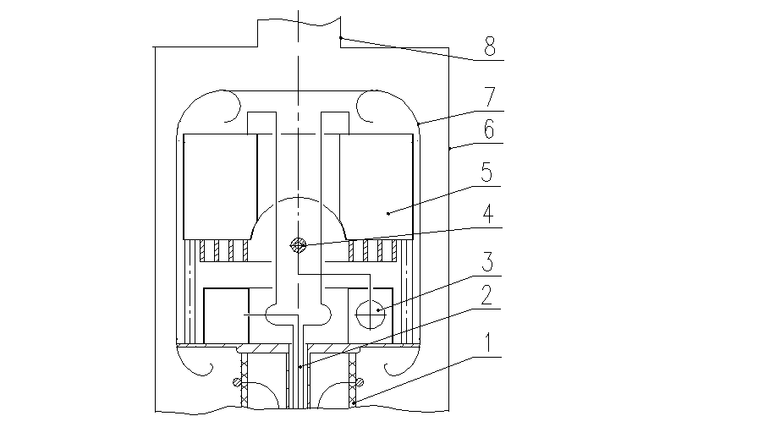 | Fig. 7.  The prototype of accelerator-tandem.  1 – bushing metal-ceramic insulator,  2 – buckle-pipe,  3 – gas volume with leak,  4 – stripping tube,  5 – nitrogen pump,  6 – “ground” electrode,  7 – high voltage electrode,  8 – pump neck.
Gas of the stripping target is condensed on the surface of cryogenic pump cooled to temperature 77 °К. The stripping tube and gas volume with leak are situated very close to nitrogen pump. Thermal regimes of the stripping tube and gas volume with leak are substantially different in the experiments with pulsed H⁻ beam on the prototype and in experiments with DC H⁻ beam in big tandem. In the experiments on the prototype the heat flux on the tube in case of pulsed beam is minimal. Therefore the temperature drop of the stripping tube and gas volume down to target gas condensation temperature is inadmissible. The energy deposition during operation with DC beam caused by precipitation of beam tails on the tube wall (especially if take into account the desirable reduction of the tube diameter) can exceed substantially the calculated above power deposition levels. In this case it's necessary to estimate the maximal power which can be removed from the stripping tube for it's cooling.

Estimation of the stripping tube and gas volume temperature
For normal operation of stripping target it's necessary to keep temperature of the stripping tube, gas volume with leak and gas supplying tubes higher than temperature of gas condensation. For СО₂ for example this temperature is 195 °К.
The stripping tube is mounted on the shell of gas volume, the temperature of which is determined by radiation heat fluxes between shell and nitrogen trap, between "ground" electrode and outer frame through the heat shield (it's role plays the high voltage electrode) and by heat penetration from the environment through ceramic insulator.
The effective area of upper part of gas volume shell giving the heat to nitrogen pump by radiation is 1000 cm² approximately, the effective area of nitrogen trap receiving the heat radiation from the outer frame – 1600 cm², the area of shell being heated up by radiation through the heat shield – 2300 cm², the area of "ground" electrode, taking part in radiation heat exchange with gas volume shell – 10000 cm². For the thermal conductivity of ceramic insulator λ = 0,04 W m^{–1} K^{–1} and emissivity coefficient of stainless steel surface equal to 0,1 the temperature of gas volume will be 260 °K. Taking into account the high voltage electrode cooling by radiation from its surface to the surface of cryogenic pump reduces the temperature of gas volume to 250 °К in case of absence of radiation heat penetration from the outer environment through the high voltage electrode.
The stripping tube mounted on the shell of gas volume has lower temperature, defined by heat irradiation from the part of its surface to the nitrogen pump and by heat conductivity (through it's attachment point [14, 33] and gas supplying tube) on gas volume. The upper surface of the stripping tube "looks" at the end surface of nitrogen pump with temperature 77° K. The finned surface of nitrogen pump blocks the radiation heat exchange between the tube and high voltage electrode. Neglecting the small heat exchange with "ground" electrode through the heat shield (high voltage electrode), the tube temperature not less than 240 °К was obtained in calculations.
The described design of the target unit provides tandem operation in experiments with pulsed Н⁻ source without freezing of target gas in the stripping tube and inside the gas volume.
Forced cooling of the stripping tube
Let consider the transformer oil as a heat carrier for the forced cooling of the stripping tube in stationary mode. It has big enough breakdown strength. Oil input inside the central high voltage electrode is realized through polyethylene tubes, having the limited mechanical strength at a temperature higher than 60 °С. At a heat carrier consumption R = 1 l/min and oil input and output temperature difference ΔT_{oil} = T_{oil out} – T_{o in} = 40 °C T_{oil out} = 60°C T_{oil in} = 20°C the heat removal is: P = c ρ R ΔT_{oil} ≅ 1 kW, where ρ = 870 kg/m³ – oil density, с = 1750 J kg^{–1} K^{–1} – its heat capacity. For 5 kW heat removal the oil consumption R ≅ 5 l/min is necessary.
In order to increase the heat removal, the outer diameter of copper stripping pipe 250 mm in length is increased to 16,5 mm. All the tube excepting its center is winded by copper cooling pipe with good heat contact between them. The outer diameter of cooling pipe is 6 mm, the inner 5 mm. For the oil velocity 4 m/s and the heat emission coefficient α = 2000 W m^{–2} K^{–1} [32] the average temperature difference between the stripping tube wall and oil will be 36°C [30, 31]. The wall temperature of the stripping tube will be 80 °C, it will allow to use transformer oil without its special refinement from water. The pressure drop on supplying polyethylene tube of 4 m length and 1 cm in diameter is 0,1 bar., it much less than the pressure drop 3 bar. on the cooling pipe for 4 m/s oil velocity. It's known that pressure drop of 3 bar does not lead to the destruction of polyethylene tube with heat carrier.
So, the 5 kW power removal from the high voltage electrode can be obtained. The further increase of heat removal requires the rise of oil velocity in the system, which results in almost square (by velocity) pressure rise.
Argon gas target with recirculation
Any more variant of the stripping target is connected with the use of turbo-molecular pump installed directly inside the high voltage electrode. The industry made pumps with ~ 500 l/s pumping rate have dimensions 15 cm approximately and consume less than 1 kW power, so their application shouldn't cause any problems. The differential pumping is realized by placing vacuum resistance in front of the hole in high voltage electrode in order to reduce gas flux to accelerating gap. If this resistance is made like tube continuing the stripping one but placed on the distance of three diameters, then its conductivity will be less by an order than the gap between tubes conductivity. It will allow to pump out the most part of gas by pump and return it back from the pump output into the stripping target, i.e. to realize recirculation. In case of high capacity pump used, a set of diaphragms is more effective. The use of turbo-molecular pump allows to increase the stripping tube diameter if necessary.

Conclusion
It has been defined that gas stripping target, used for stripping of H– ions accelerated to half of total energy, is the most preferable for the electrostatic tandem-accelerator with vacuum insulation on energy of protons up to 2,5 MeV and with dc current up to 40 mA. Three variants of gas stripping target were chosen for further development and realization:
1. Argon gas target with external pumping. This target is attractive by the lack of dissociation effects, but requires to provide beam passage less than 10 mm in diameter on 400 mm length.
2. Argon gas target with turbo-molecular pump in immediate vicinity and with recirculation. It allows to weaken requirements on beam transportation and improve gas conditions.
3. Target with cryogenic nitrogen pump in immediate vicinity. It also allows to weaken requirements on beam transportation, but its use is accompanied by many effects which require experimental testing.
The final choice of the stripping target variant will be done after prepared experiments on the prototype of accelerator tandem.

References
- B. Baynov et al. Accelerator based neutron source for the neutron-capture and fast neutron therapy at hospital. Nucl. Instr. and Meth. in Phys. Res. A 413/2-3 (1998) 397-426.
- I. N. Slivkov. Electrical insulation and vacuum discharge. M.: Atomizdat, 1972.
- Tables of physical values. Under red. of I. K. Kikoin. M.: Atomizdat, 1972.
- L. Picardi еt al. Preliminary design of a technologically advanced and compact synchrotron for therapy. RT/INN/94/20.
- Yu. M. Shirokov, N. P. Udin. Nuclear Physics. M.: Atomizdat, 1972.
- N. Dikansky et al. Influence of the sign of an ion charge on friction force at electron cooling. European particle accelerator conference, 1988, Rome, V1, p. 529-531.
- V. Belov еt al. Neutron producing target for neutron capture therapy. Proc. of 9th Intern. Simposium on Neutron Capture Therapy for Cancer, October 2-6, 2000, Osaka, Japan, p. 253-254.
- G. Silvestrov. Lithium lenses for muon colliders. Proc. of 9th Advenced ICFA Beam Dynamics Workshop, 1995, Montauk NY, USA.
- B. A. Diachkov and others . Instruments and Experimental Techniques 2 (1974) 35.
- B. A. Diachkov and others Charge exchange sodium target with big aperture. Instruments and Experimental Techniques 5 (1978) 37.
- G. I. Skandinavi. Physics of dielectrics (in strong fields). M. Publishing house of physics and mathematics literature. 1958.
- C. Barnet et el. Atomic data for controlled fusion research. Oak Ridge National Laboratory, ORNL-5206, 1977.
- V. I. Radchenko, G. D. Vedmanov. Ions and hydrogen atoms scattering in gases. J. Exper. and Theor. Physics 107 (1995) 3.
- B. Z. Persov. Design principles of the experimental physical installations. Novosibirsk Univ. Novosibirsk. 1993.
- Vacuum technology. Reference book. Under red of E. S. Frolov and V. E. Minaychev. M.: Mashinostroenie, 1992
- M. Devien. Flows and heat exchange in rarefied gases. M., 1962.
- S. D. Deshman. Scientific fundamentals of vacuum engineering. M.: Mir, 1964.
- L. G. Loytsyasky. Gas and liquid mechanics. M.:, Nauka 1978.
- A. A. Kabantsev, V. G. Sokolov, S. Yu. Taskaev. Reduction of target plasma density during the injection of atomic beams into magnetic bottle. Plasma Physics 21 (1995) 775.
- C. Hojvat et al. IEEE Trans. On Nucl. Sci., №5-26, № 3/2 (1979) 4009.
- H. Tawara and A. Russek. Rev. Modern. Phys. 45 (1973) 178.
- Atomic and molecular processes, under red. of D. Beits, M.: 1964.
- G I Dimov. ЖТФ 36 (1966) 1239.
- V E Minaychev. Vacuum cryo-pumps. M.: Energiya, 1976.
- G. L. Saksagansky. Ultra high vacuum in radiophysical apparatus building. M.: Atomizdat, 1976.
- M. D. Gabovich and others J. Theor. Physics 47 (1977).
- B. N. Smirnov. Atomic collisions and elementary processes in plasma. M.: Atomizdat, 1968.
- M. D. Gabovich. Physics and technology of plasma ion sources. M.: Atomizdat, 1972.
- L. Slovetsky. In coll. of Plasma Chemistry, issue. 1, Atomizdat, 1974.
- A. T. Tunik. Cooling of radio-electronic equipment by liquid dielectrics. M.: Sov. Radio, 1973.
- V. S. Zhukovsky. Fundamentals of heat transfer theory. M.–L.: Gosenergoizdat, 1960.
- S. Krasnoschekov, A. Sukomel. Book of problems on heat transfer. M.: Energiya, 1975.
- Yu. Shlykov, E. Ganin. Contact heat exchange. M.-L.: Gosenergoizdat, 1963.

